NAME: EKENG, AKANINYENE IME
COURSE: JUNIOR SECURITY ANALYST INTRO
COHORT: NOVARA 28 NOVERMBER 2025
DATE:18/02/2026

AIM: To understand the daily responsibilities, workflow, and required skills of a Junior Security Analyst within a Security Operations Center (SOC), and to gain practical insight into real-world security operations.

INTRODUCTION
A Junior Security Analyst is an entry-level cyber security professional responsible for monitoring security alerts, analyzing suspicious activities, and supporting incident response activities within a SOC.
The role focuses on identifying potential threats, reducing false positives, and escalating verified incidents to senior analysts.

MATERIALS
- TryHackMe account
- Junior Security Analyst Intro lab access
- Web browser
- Basic cybersecurity knowledge

PROCEDURES
Step 1: Junior Security Analyst Journey
  - I accessed the lab environment.
  - I studied the career path and responsibilities of a junior analyst.
  - I understood how analysts fit into the SOC structure.
Step 2: Security Operations Center (SOC)
  - I learned about SOC operations.
  - I reviewed how alerts are generated and monitored.
  - I understood escalation processes.
Step 3: A Day in the Life of a Security Analyst
  - I simulated and reviewed multiple security alerts.
  - I analyzed suspicious login attempts and phishing cases.
  - I identified indicators of compromise (IOCs).
  - I classified alerts as true or false positives.
  - I escalated confirmed incidents.
  - I documented my findings properly.

OBSERVATION
  - I observed that, most alerts require careful verification before escalation.
  - I observed that, false positives are common in SOC environments.
  - I observed that, log correlation is important for identifying real threats.
  - I observed that, clear documentation improves investigation efficiency.
  - I observed that, communication between teams is essential for quick response.
  - I observed that, time management is important due to high alert volume.

PRECAUTIONS
  - Do not ignore alerts without proper investigation.
  - Avoid misclassification of true threats.
  - Follow escalation protocols strictly.
  - Maintain confidentiality of sensitive information.
  - Ensure accurate documentation in ticketing systems.
  - Double check logs before making conclusions.

CONCLUSION
In conclusion, the Junior Security Analyst Intro practical on tryhackme provides a clear understanding of the responsibilities and workflow of an entry-level SOC analyst. It demonstrated how security alerts are handled, investigated, and escalated within the professional environment.

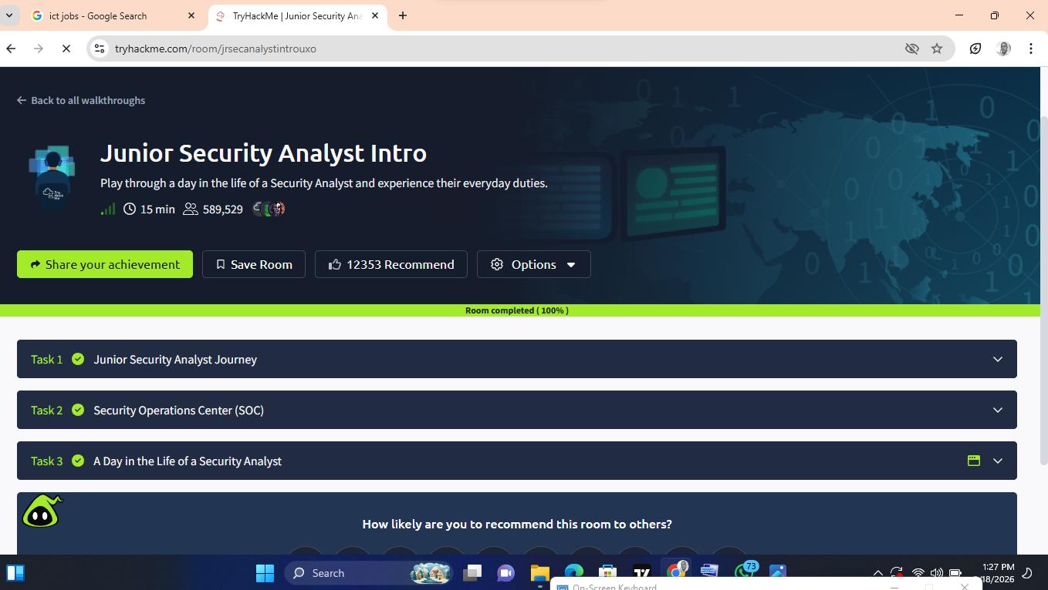
SCREENSHOT OF MY SUCCESSFUL COMPLETION.

